Lab1:-

Question 1:-



Question 2:-

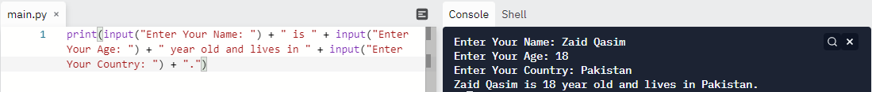

Lab 2:-

Question 1:-

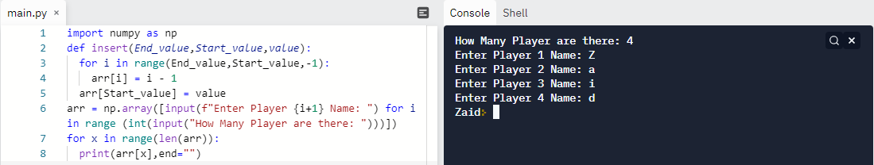

Question 2:-

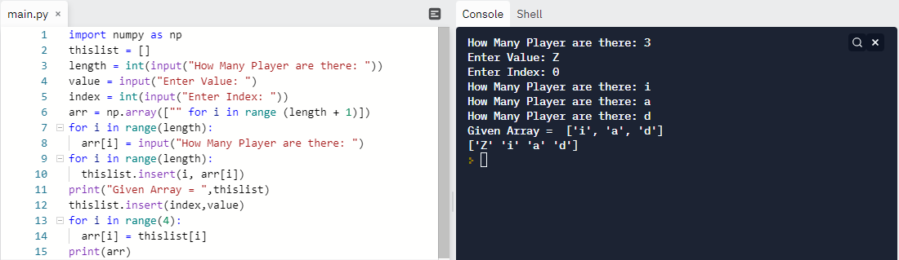

Question 3:-

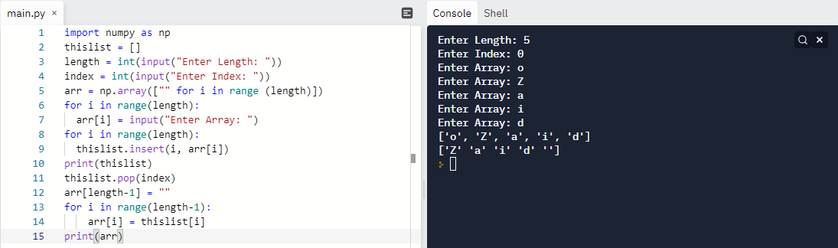

Lab 3:-

Question 1:-

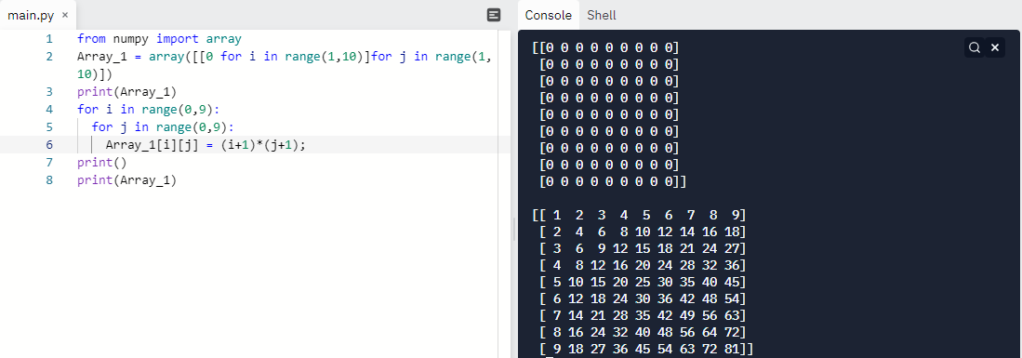

Question 2:-

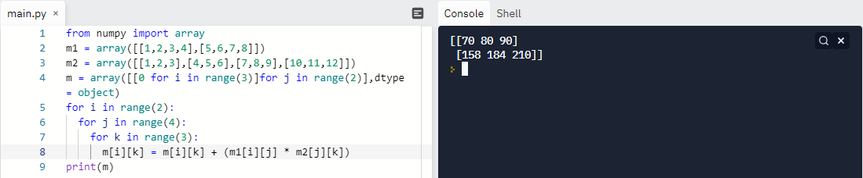

Question 3:-

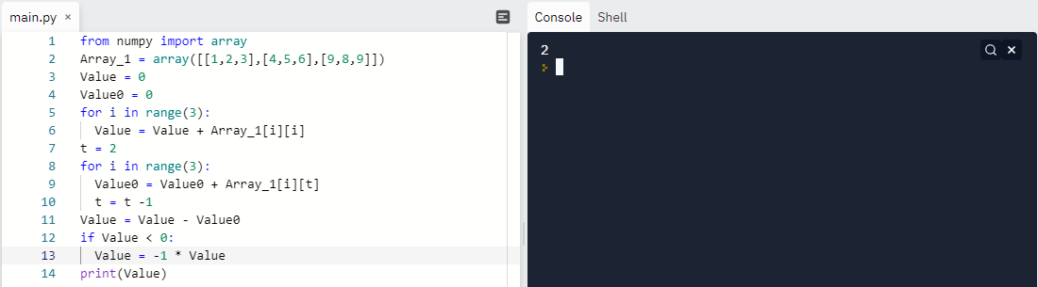

Lab5:-

Question 1:-

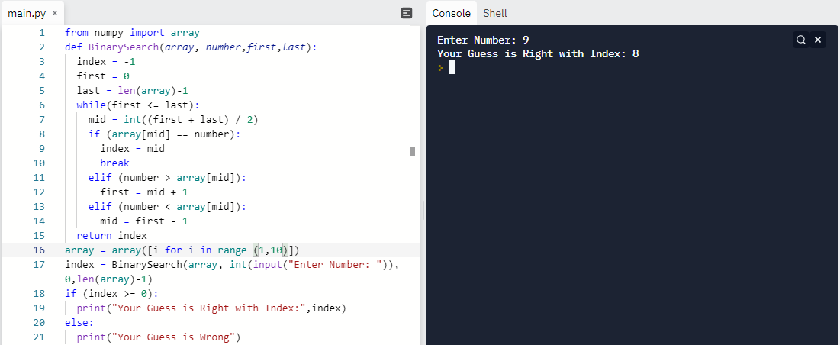

Question 2:-

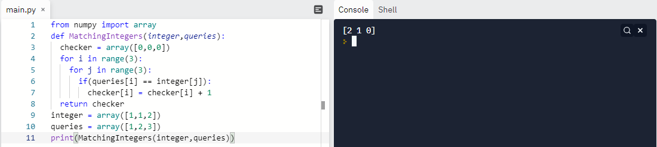

Lab6:-

Question 1:-

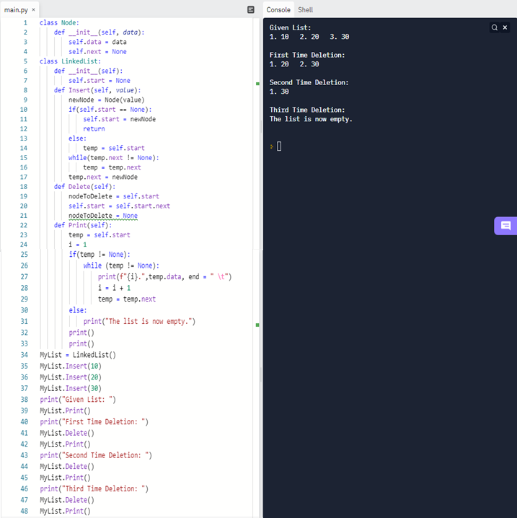

Question 2:-

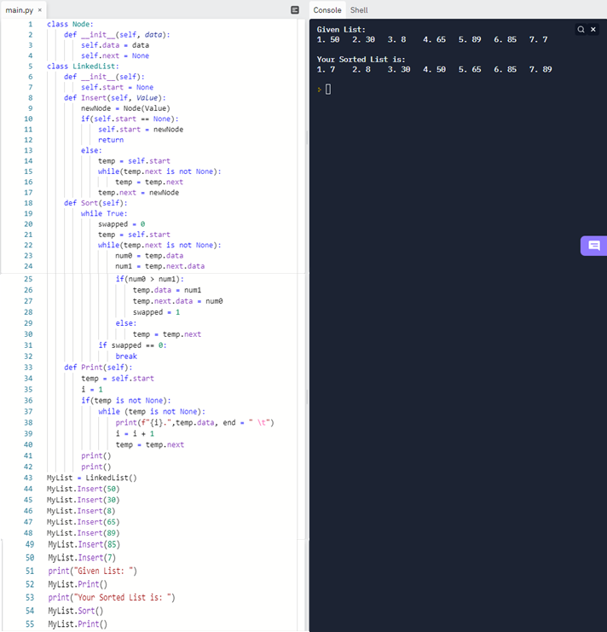

Lab7:-

Question 1:-

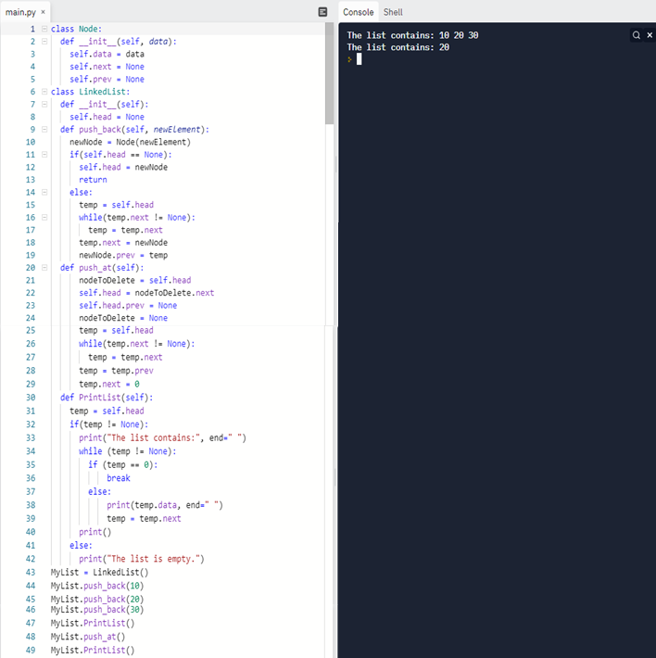

Question 2:-

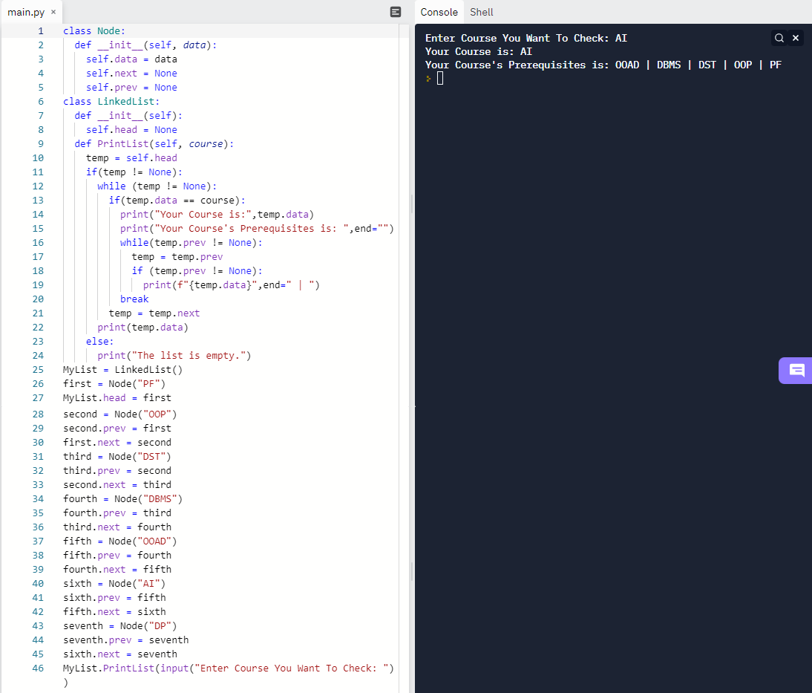

Lab8:-

Question 1:-

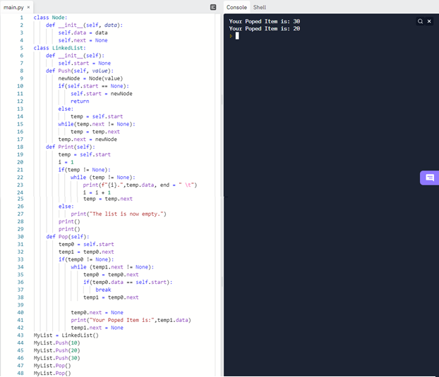

Question 2:-

